**Table of Contents**

**AIR TICKET SYSTEM** 3

**Introduction** 3

**Overview of Application** 3

**Problem Statement** 3

**Tools Used** 4

**Methodology** 5

**Requirement Analysis:** 5

**Feasibility Study** 6

**Planning** 7

**Gantt Chart** 7

**Network Diagram** 8

**Design (class diagram, use case, activity, DFD, ER)** 9

**Class Diagram** 9

**Use Case Diagram** 10

**Activity Diagram** 11

**DFD** 12

**ER Diagram** 13

**Conclusion** 14

**Table of Figures**

Figure 1 Waterfall Model 5

Figure 2 Gantt Chart 7

Figure 3 Network Diagram 8

Figure 4 Class Diagram 9

Figure 5 Use Case Diagram 10

Figure 6 Activity Diagram 11

Figure 7 Level 0 DFD 12

Figure 8 Level 1 DFD 12

Figure 9 ER Diagram 13

# **AIR TICKET SYSTEM**

## **Introduction**

Skipping the long queues at airport counters and booking your flight through a few clicks from anywhere in the world is like a magic of online air ticket systems. They've revolutionized travel, making it faster, easier, and more accessible for everyone.

Online air ticket systems are software platforms that allow us to search, compare, and book flights directly through airline websites or travel aggregators. We can select destinations, dates, fares, and even choose our preferred seats, all from the comfort of our couch.

## **Overview of Application**

The ARS is a useful software application designed to streamline the airline operations. It includes several key features that are essential to manage the airline operations and they are as follows:

Flight Reservations: Users can easily reserve flights by entering flight details and passenger information which will update the seat availability.

Flight Cancellations: If the user wants to cancel the flight, the system can update the seat availability and manage any related fees.

Real-Time Seat Availability: The system provides real-time updates about seat availability, allowing the airline operators to manage flights more effectively.

## **Problem Statement**

The Airline Reservation System aims to address various challenges faced by airlines, including:

Manual Reservation Processes: Many airlines still rely on manual reservation processes that might lead to inefficiencies and errors, such as overbookings or missed reservations.

Ineffective Seat Allocation: Without a centralized system, airlines may struggle to allocate seats effectively, resulting in less utilization of flight capacity and lower customer satisfaction.

Limited Passenger Data Analysis: Airlines may face challenges in analyzing passenger data that can degrade their ability to make informed decisions on flight scheduling and services.

These challenges can impact airline operations, leading to inefficiencies, lower customer satisfaction, and missed revenue opportunities.

## **Tools Used**

The development of the Airline Reservation System involves using a range of tools and programming languages, including an efficient technology stack known as the MERN stack (MongoDB, Express.js, React.js, Node.js) that can optimize development and enhance system performance.:

User Interface (UI): React.js can be used to build a dynamic and interactive user interface on the frontend side. Combined with HTML and CSS, it ensures the creation of a responsive and visually appealing frontend that enhances the user experience.

Server-Side Logic: Node.js, along with Express.js, can be chosen to handle the server-side logic. Node.js provides an event-driven, non-blocking functionality, and Express.js simplifies the creation of APIs, facilitating the perfect integration of frontend and backend components.

Database Management: MongoDB can be selected as a database management system for the ARS project. Its NoSQL nature allows for flexible and efficient storage of data related to flights, reservations, and user information in a JSON-like format.

## **Methodology**

For the development of the Airline Reservation System, a structured approach using the Waterfall methodology can be employed.



Figure 1 Waterfall Model

### **Requirement Analysis:**

Requirement analysis is a critical phase in the development of the Air Ticket System. It involves a systematic process of gathering, documenting, and analyzing the needs and expectations of stakeholders, including bank employees, managers, and customers. The primary objectives of requirement analysis in this context are as follows:

Identify Stakeholder Needs:

The first step is to identify and engage with all relevant stakeholders, including end-users, managers, and IT personnel, to understand their needs and expectations from the system. This may involve conducting interviews, surveys, and workshops.

Document Requirements:

All identified requirements are documented in detail. This includes functional requirements (what the system should do) and non-functional requirements (performance, security, usability, etc.).

Prioritize Requirements:

Not all requirements are of equal importance. Prioritization helps in determining which features should be developed first and which can be deferred to later phases.

Resolve Conflicts:

Sometimes, stakeholders may have conflicting requirements. It's essential to resolve these conflicts through negotiation and consensus-building.

Validation:

The gathered requirements are validated with stakeholders to ensure that they accurately represent their needs and expectations. This iterative process helps in refining and improving the requirements.

### **Feasibility Study**

A feasibility study is conducted to assess the viability and practicality of the Air Ticket System project. It evaluates various aspects, including technical, operational, and economic feasibility, to determine whether the project should proceed. The following aspects are considered in the feasibility study:

Technical Feasibility Assess whether the chosen technologies and tools are suitable for the project's requirements. Ensure that the development team has the necessary expertise in these technologies. Analyze the compatibility of the new system with existing systems and infrastructure within the bank.

Operational Feasibility Assess the willingness of bank employees and customers to adapt to the new system. Identify potential resistance to change and plan change management strategies. Analyze the training needs of bank staff to ensure they can effectively use the new system.

Economic Feasibility Cost-Benefit Analysis: Conduct a cost-benefit analysis to compare the project's costs (development, implementation, maintenance) against the expected benefits (cost savings, increased revenue, improved customer satisfaction).

## **Planning**

In the planning phase of the Airline Reservation System (ARS) project, two essential tools are employed to facilitate effective project management and scheduling: the Gantt Chart and the Network Diagram.

### **Gantt Chart**

In the Airline Reservation System project, Gantt Chart outlines project tasks and their dependencies, providing a timeline view of the project's milestones.

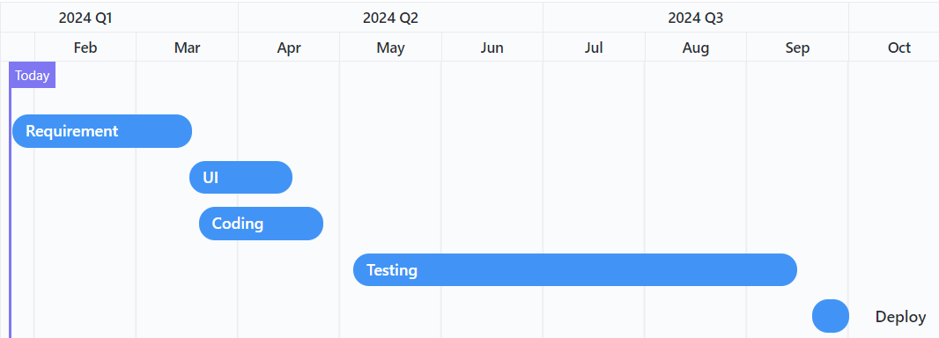

Figure 2 Gantt Chart

### **Network Diagram**

A Network Diagram visually represents project tasks and their relations, aiding project managers in understanding activity flow for the Airline Reservation System.

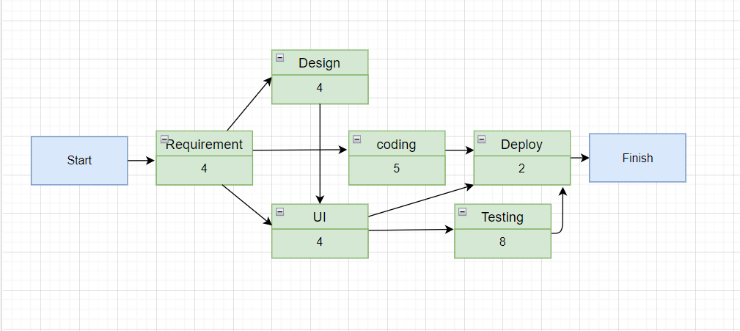

Figure 3 Network Diagram

## **Design (class diagram, use case, activity, DFD, ER)**

In the design phase of the Airline Reservation System project, various diagrams are created to articulate the system's architecture, components, and interactions.

### **Class Diagram**

A Class Diagram is a structural diagram that can visualize the static structure of the Airline Reservation System by depicting classes, their attributes, methods, and relationships.

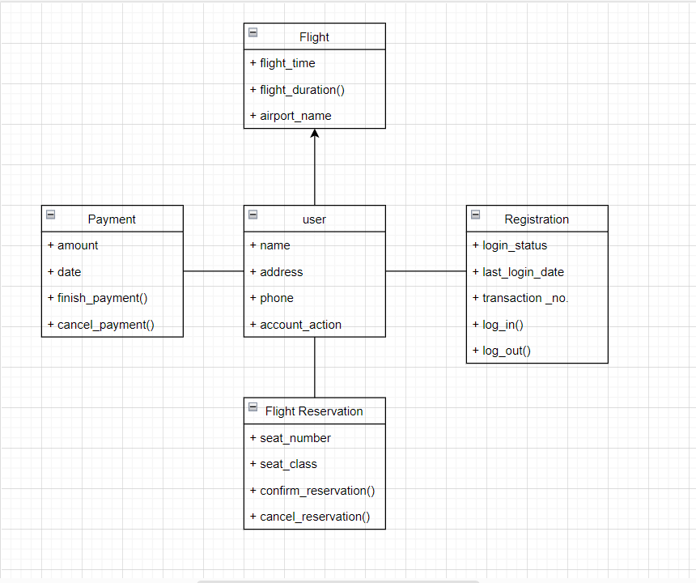

Figure 4 Class Diagram

### **Use Case Diagram**

A Use Case Diagram is a UML diagram that visualizes the interactions between actors (users or external systems) and the functionalities (use cases) within a system. It helps in identifying and organizing system requirements.

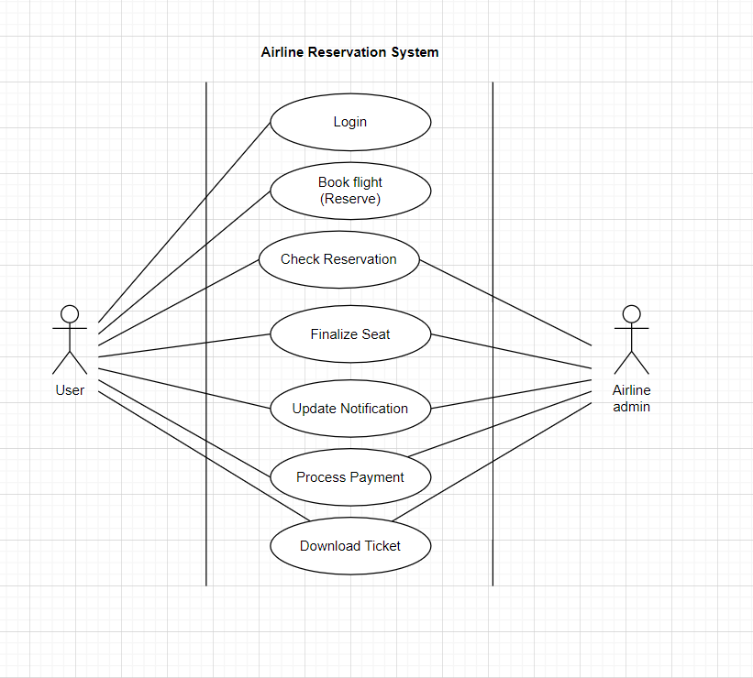

Figure 5 Use Case Diagram

### **Activity Diagram**

An Activity Diagram is a UML diagram that illustrates the flow of activities or processes within the Airline Reservation System.

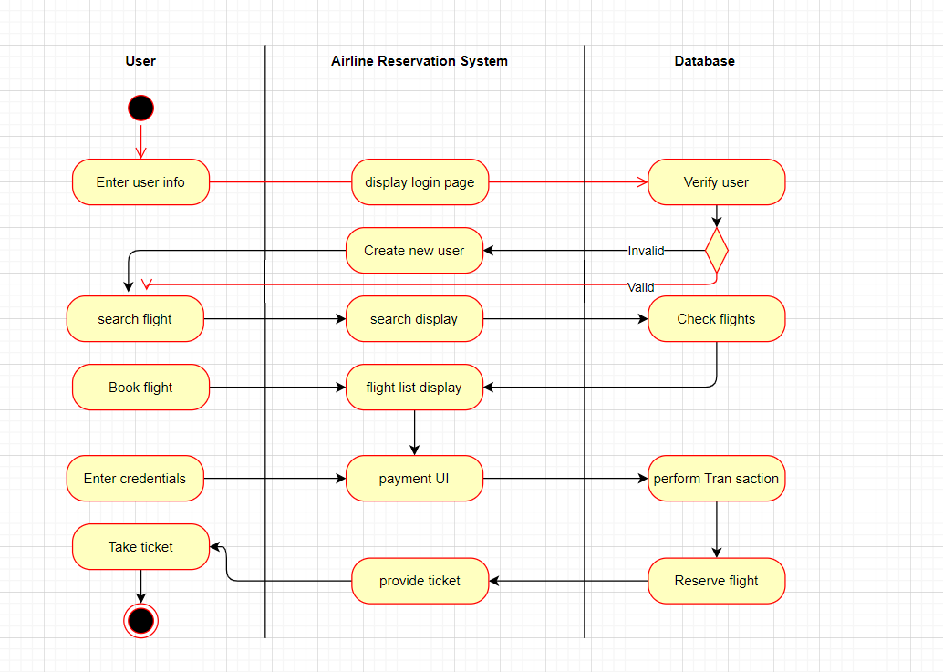

Figure 6 Activity Diagram

### **DFD**

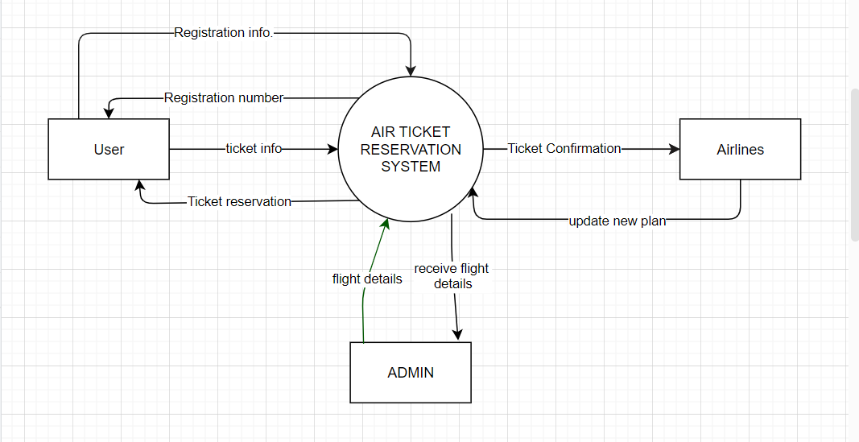

Figure 7 Level 0 DFD

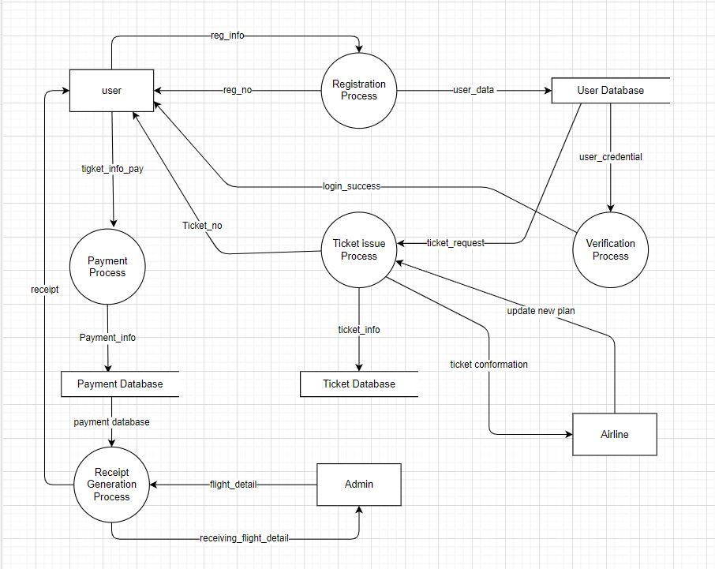

Figure 8 Level 1 DFD

### **ER Diagram**

An Entity-Relationship Diagram is a visual representation of the relationships among entities in a database.

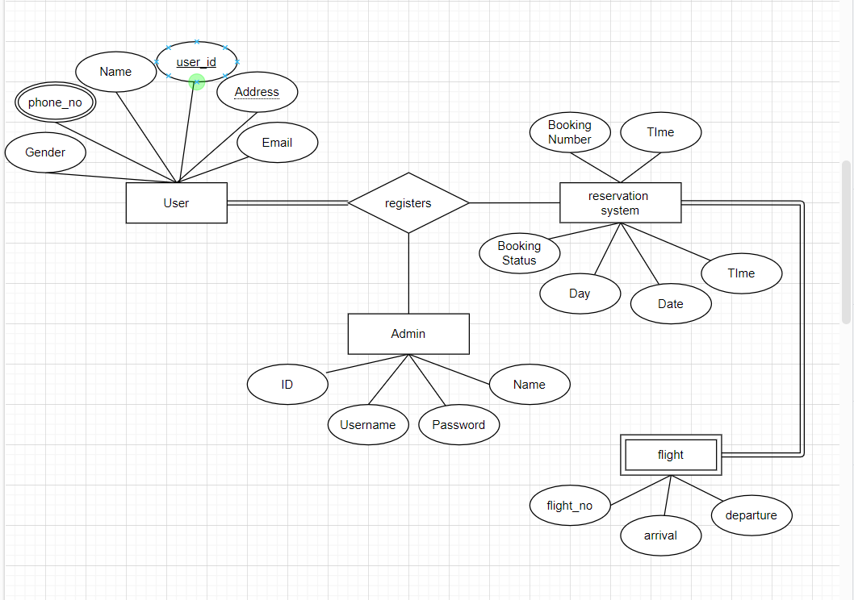

Figure 9 ER Diagram

## **Conclusion**

In conclusion, the development of an Airline Ticket System is a substantial

endeavor requiring meticulous planning, analysis, and design. This project aims to

address the challenges faced by the airline industry, including complex reservation

processes, potential inefficiencies, and the need for a streamlined and user-friendly

system.

Through comprehensive requirements analysis and a thorough feasibility study, we have

gained valuable insights into the functional and technical requirements of the system. The

feasibility assessment considers the operational, technical, and economic aspects,

ensuring that the proposed Air Ticket System is viable and beneficial in multiple dimensions.